|  |
| --- |
| **National University of Computer and Emerging Sciences** |
| In Lab Exercise 3  **“joins (outer & inner), group by, aggregation”** |
| Database Systems Lab |
| Fall 2020 |

Department of Computer Science FAST-NU, Lahore, Pakistan

**Exercise**

For this exercise use the following schema, the script to create this schema and populate data is given in ATM.SQL file

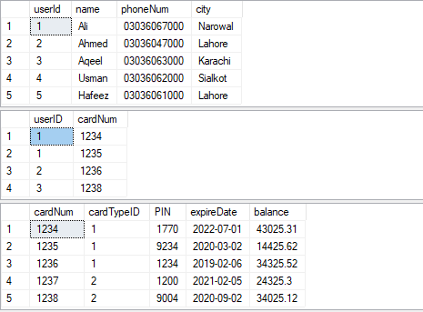

User

UserCard

Card

Transaction

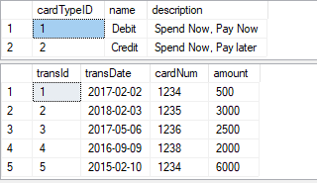

CardType

**Inlab**

1. Find the total number of unique users of each **cardType**.
2. Show the card numbers and user names whose balance is in the range (Min: 2000, Max: 4000).
3. Show the name of those users who do not possess any card.
   1. using set operation
   2. using join
4. Show the id of those cards along with the card type name and the owner’s name for which no transaction has been carried out in the last year. (Do not hardcode the year as 2018. To get current year you can use year (**getdate()** ) ).
   1. using set operation
   2. using join
5. For each card type, show the total number of cards whose total sum of transaction amount is greater than 6000. Consider only the transactions carried out in the period 2015-2017.
6. List the user id, name, phone number, city of those users whose card is expiring within the next 3 months. Also show the card number along with card type name.
7. Show the user id and name of those users whose total balance is equal to or greater than 5000.

It is possible that a user has more than 1 card. In such a case, you will have to take sum of balance of each card of the user.

1. Show those card pairs which are expiring in the same year.
2. Show those user pairs whose names’ first characters are the same.
3. Show the name and id of those users who possess both the credit card and the debit card.
4. Show the City name, number of users and the sum of amount of the users from same city.